Assignment 3: Realizing a Design

COMPSCI 345 | SOFTENG 350  
UPI: CLI501  
ID: 6019888  
Name: Chenghang Li

# Wireframe walkthrough

For the purpose of this wireframe, a fictional character and situation will be used.

Persona

* Name: John Dillinger
* Age: 45
* Sex: Male
* Background: Lives alone and works a standard work week at the office, has his front door camera hooked up to XYZ management system

Scenario

* John is at work and has just read about some recent burglaries in his neighborhood. He decides to check his home camera to make sure his house is fine. John accesses his XYZ management web application. John moves his mouse over the “Security” option in the menu, he then clicks on the “Cameras” option. John is taken to a page where he sees a live feed of his front door from the camera installed. Everything is alright to John so he closes the application.

The following pages will walk you through how John interacts with the XYZ Management System web application as described in the scenario.

**Step 1**

John opens up his XYZ Management web page and sees the following

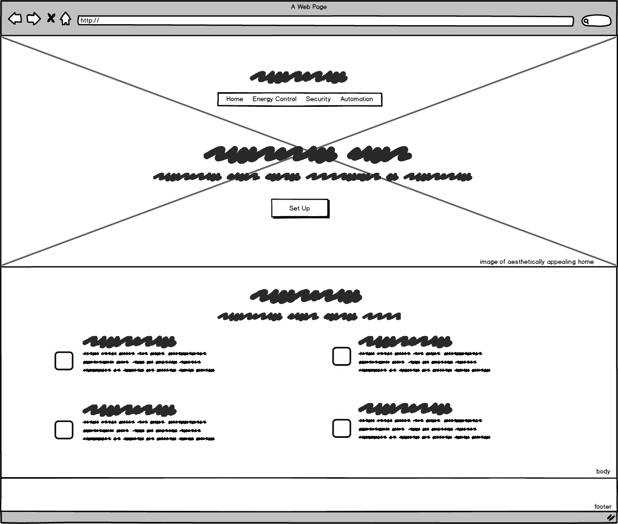

**Step 2**

John hovers his mouse over the “security” option in the menu, showing a drop menu. He then clicks on “Cameras” with his mouse

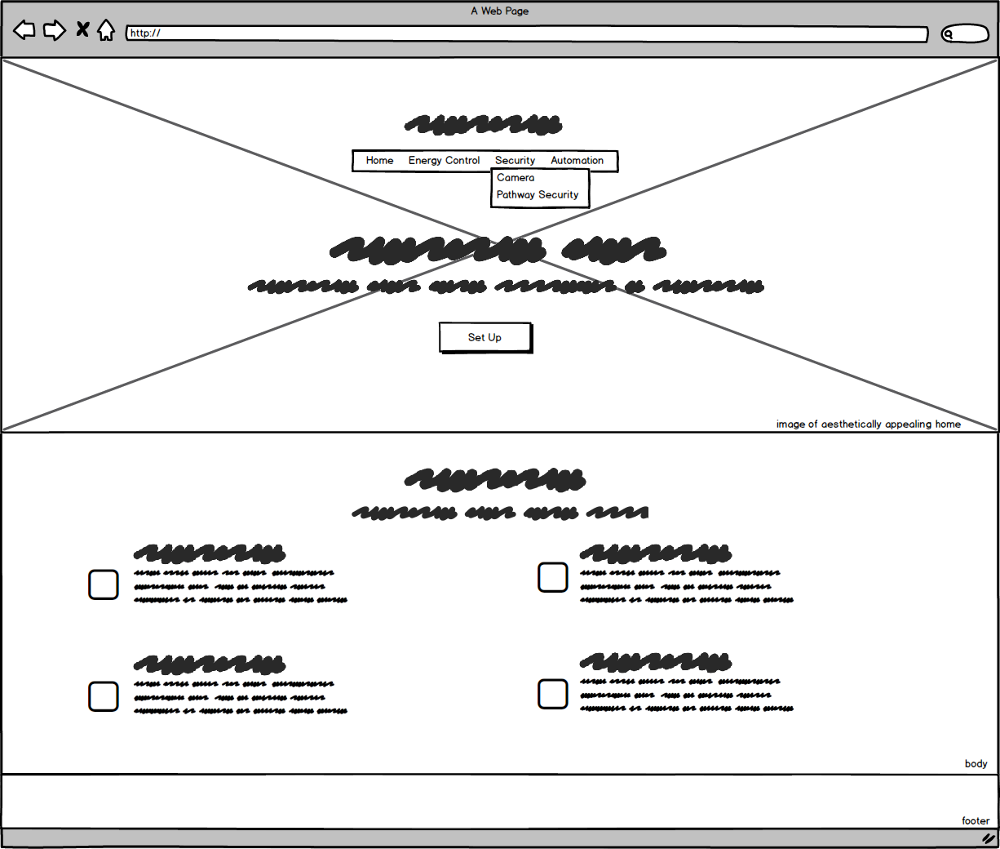

**Step 3**

John checks his live camera feed for any suspicious activity. If John finds something amiss, he can immediately click on the “Report Intruder” button below the feed corresponding to it. However, nothing is amiss and John is a smart man, so he does not click on the button.

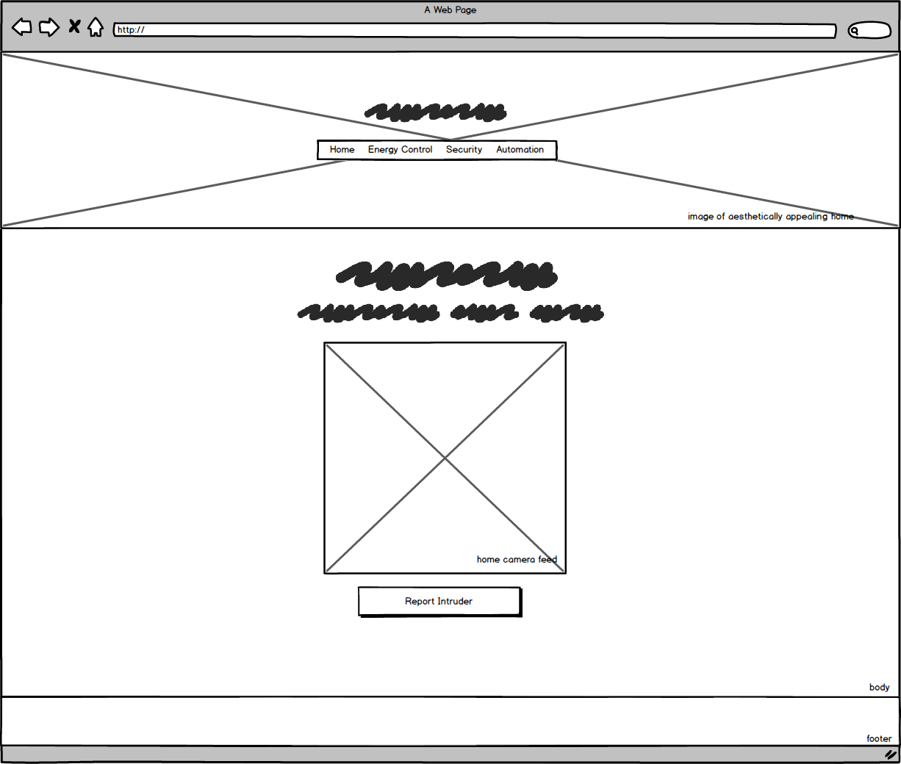

# Colour scheme

For my colour scheme of the XYZ management system’s web interface, I have decided to pursue a minimalist palette of colours which I believe represents the resourceful nature of the application whilst still remaining aesthetically appealing to its users.

* Colour Scheme Monochromatic Green
* Values #3AC984 Icons, Buttons, Menu Options and Footer

#32B777 Button Hover

* Text #555555 Body Text #FFFFFF Text on Coloured Background

In the context of modern design, minimalism is evidently prevalent; therefore, I want my web user interface to be minimalistic and modern. To achieve a minimalistic design I have utilized a monochromatic green colour schematic consisting of two analogous shades of green and maximum of four colours.

# layout scheme

For my layout scheme, I have decided to reduce the use of strokes, lines and borders; Instead I have decided to place an emphasis on Gestalt Principles of Perception.

For the image background, I utilize **The Area Principle** by enlarging it to show it is not a figure, but a ground.

As for the foreground text I use the **Horizontal and Vertical Grouping** accordingly to show which elements are related.

Utilizing the **Similarity Principle** on the home page, I have grouped the icons symmetrically and of equidistance. This helps the user realise that the icons are related.

I gave the buttons rounded shapes to give an easier aesthetic feel.  
  
I have segmented each page into three sections to retain consistency in simplicity. Header, Body and Footer.

# Resources used

**Javascript:**Init.js  
*Implements everything else*

jquery.dropotron.min.js  
jquery.min.js  
*Allows drop down box to work*

skel.min.js  
skel-layers.min.js  
*Realises CSS*

**Images:**Architecture Building Background - [*www.tes.com*](http://www.tes.com)Camera Feed Placeholder - [www.ar15.com](http://www.ar15.com)   
  
**Fonts:**FontAwesome.otf - https://fortawesome.com/  
*Icons plus text*